Instructions:

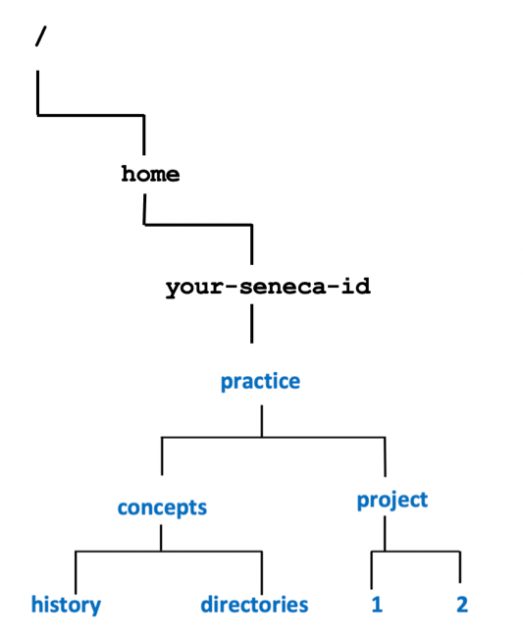
This handout is just for practice. It is the responsibility of the student to attend class to mark their own work in class when your professor takes up this exercise.
For each of the following questions, use a pathname starting from
the root directory (i.e. “/”).
Questions:
- Write a single Linux command to create the directory structure starting from your home directory from the diagram displayed on the right.
- Write a Linux command to display a detailed listing of
the history directory.
How would this command differ if you wanted to also view hidden files as well?
- Write a Linux command to change to the project directory.
What command would you issue to return to your home directory?

- Write a Linux command to copy the project directory and its contents to the history directory.
- Write a Linux command to move the directory called directories to the history directory.
- Write a Linux command to remove both directories called 1 and 2.
- Write a Linux command to remove the concepts directory and its contents.
- Write a Linux command to remove the concepts directory and prompt the user if they want to remove this directory’s contents.
- Write a single Linux command to create the following empty files in the concepts directory:
myfile.txt
yourfile.txt
thefile.txt
- Write a Linux command to view the contents of the myfile.txt text file to prove it is empty.
What is the difference between the commands: cat, more and less?
- Write a Linux command to sort the contents of a file called practice/customers.txt
- Write a Linux command to display the first 4 lines of a file called practice/customers.txt

- Write a Linux command to display the last line of a file called practice/customers.txt

- Write a Linux command to match a line containing the pattern Linux in a file called practice/customers.txt

- Write a Linux command to display unique occurrences of consecutive lines in a file called practice/customers.txt
- Create a table listing each Linux command, useful options that are displayed near the top of this tutorial labelled: Tutorial Reference Material

